CITY OF BETHLEHEM

INTER-DEPARTMENTAL CORRESPONDENCE

SUBJECT: Request to APPLY FOR NORTHAMPTON COUNTY OPEN SPACE INITIATIVE GRANT FUNDS, PARK REHAB

TO: COUNCIL MEMBERS, All

FROM: RALPH CARP, PARKS AND PUBLIC PROPERTY DIRECTOR

DATE: MARCH 23, 2016

Esteemed members of Council,

Please find the attached proposed resolution. This resolution will allow our office to apply for Northampton County Open Space Initiative grant money that will be used to refurbish Parham Park in south Bethlehem. Our required match of 50% will be provided by the CDBG funding.

Please contact my office should you have any questions.

Thank you.

Copy to: File By: 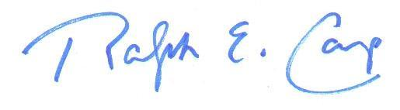

Ralph Carp, Parks & Public Property Director

Attached: Resolution

RESOLUTION NO. 2016 -

BE IT RESOLVED by the Council of the City of Bethlehem that,

WHEREAS, The City of Bethlehem recognizes that the City needs to provide park and recreation facilities that contribute to the quality of life and economic health of our community; and

WHEREAS, the County Council of Northampton County has established the Northampton County Open Space Initiative supported by a referendum overwhelmingly passed by Northampton County Voters on November 2, 2002; and

WHEREAS, the program provides for funding grants that may be used by the municipality to acquire land for park purposes and for park development; and

WHEREAS, the City of Bethlehem, Northampton County, Pennsylvania wishes to participate in the Municipal Park Acquisition and Development Program; and

WHEREAS, the municipality will have available $90,000, its required match,

NOW, THEREFORE, BE IT RESOLVED by the governing body of the City of Bethlehem, Northampton County, Pennsylvania, as follows:

1. That the City of Bethlehem, Northampton County, Pennsylvania hereby approves the filing of an application for funds under the Park Acquisition and Development Program.

2. That Ralph Carp, Director of Parks and Public Property, is hereby authorized and directed to execute and file the appropriate forms with the Northampton County Open Space Advisory Board.

Sponsored by: ____________________________

____________________________

ADOPTED BY COUNCIL THIS day of , 2016.

____________________________
President of Council

ATTEST:

_________________________
City Clerk

